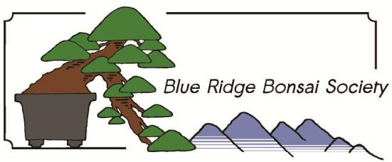

Name
BONSAI DATA SHEET

Common Name Botanical Name Date Tree Acquired Age at Time of Acquisition Source or Location of Material
General Information (fast vs slow growing, tolerant of heavy pruning vs failure to backbud vs length of dieback, tolerance for wire, etc)

Water requirements

Potting Information (soil mix; % of each component, repotting schedule)

Feeding Information (organic vs chemical; frequency)

Insect and Fungus Control Information (frequency; specific problems to look out for)

Wintering Information (special wind protection needs? outdoors vs indoors?)

BONSAI DEVELOPMENT HISTORY

Style of tree (projected or actual)

Review and Comments as of (date)

General information (how big will this tree eventually be? How tall, trunk diameter?)

Mark front (location of visible roots, lean of trunk, branch position)

Nebari (distribution of roots; possible future root graft?

Trunk (creating taper; avoiding reverse taper)

Apex (identify new leaders for a possible future apex; plan for minimizing appearance of an obvious trunk chop)

Plans for Development as of (date)
Bonsai pot (type of pot, projected angle of tree in pot)

Sacrifice branches (present and future)

Drawings (how the tree looks now; use separate sheet for drawings as the tree develops and in the projected finished form)

