Pinching Japanese black pine candle.
This technique is not decandle. It is a pre decandle technique. Break the longer candle down to about the same length as the other candles on the tree.
It will slow down the growth on strong area. And it will prevent the branch to get too big.
If the needle start to get too long, you can use scissors to cut them instead of braking them
Break about half or more . it depends on how strong it is. The stronger the candle, the remain of the candle should be shorter.

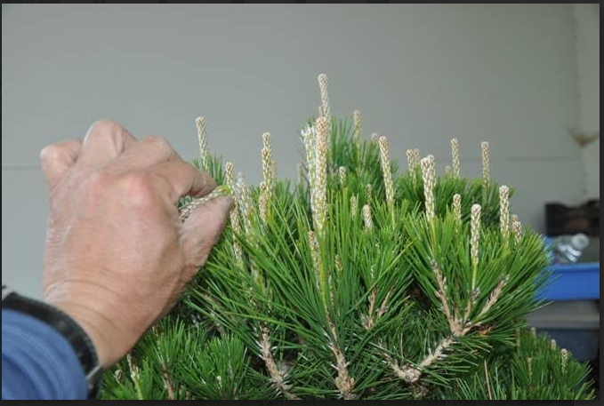

May

Spring Wiring-Deciduous Trees: The middle part of May is a good time to wire deciduous, fruiting and flowering trees. Although heavy bending must be done with caution as the cambium can easily be separated in spring, slight cracks or light breaks in a branch heal quickly because the sap is active.

Because deciduous, flowering and fruiting trees grow fast this time of year, aluminum wire works best for most branches while copper wire wrapped in paper works for heavier branches. Quick growth means that the wire will stay on for a short amount of time. Aluminum wire is easier to unwind than copper wire and it will not stain the bark or branches of these trees.( this technique is also apply to tropical trees in general)

Different styles of deciduous trees require varying degrees of movement. Attractive curves in the trunk and/or branches raise the value of these trees, including the subtle movement of zelkova branches that rise from a straight trunk. The majority of deciduous and fruiting trees from nurseries usually have straight trunks and branches and poor nebari that is not suitable for high quality bonsai. One of the best way to produce quality deciduous trees is to start from small seedlings or cuttings and train the trees when they are young. After making curves in the trunk of a young tree, plant it in the ground to thicken the trunk and train the branches once the trunk reaches an acceptable size. The other medthod is to air layer them.

Most flowering and fruiting trees can be wired and trimmed at the same time. The new growth left on the trees will be mature enough to carry flowers and fruit the following season.

Spring Conifer Care: Junipers respond best to copper wire. Be careful when you wire junipers with thin bark, such as needle juniper and California juniper, and avoid heavy twisting. Although junipers with thick bark can handle bends better than those with thin bark, too much bending in spring can damage the cambium enough to kill a branch.

Before pinching a juniper, make sure you know the proper care for the variety you are working on. For scale junipers, including shimpaku, California and sierra junipers, pinch off new growth shoots only after they elongate at least one inch past the branch’s outline. A lack of long shoots may indicate that the tree is not particularly strong, or that it is too early for pinching. If the majority of a scale juniper’s growth is juvenile, this often indicates that the tree is under stress or has been pinched too much. Leave these trees alone until mature, scale foliage returns. Again, you only pinch finished tree.

Needle junipers are scarce in the United States. These varieties are pinched with sharp scissors, leaving about 1/8 – ¼ of an inch of new growth. The new growth will be slightly lighter in color than the old growth. This time-consuming process can be completed 2-3 times a year, depending on how fast the tree grows. In summer and fall, stronger growth can be controlled by pulling out the center of new shoots. Needle junipers are also repotted at around the end of May.

San Jose and procumbens junipers may have both scale and needle growth. In Japan, mature trees are first pinched as needle junipers, and pinched through the rest of the growing season as scale junipers.

Cryptomeria too is pinched like needle junipers, only this variety is touchier. If scissors are not sharp, cut branches may die back to the previous intersection. If growth becomes too dense, small branches will die. Cryptomeria branch pads are shaped like needle juniper pads.

Keep Japanese black pines well watered and fertilized in preparation for decandling. These trees must be in great shape to respond well to decandling. If some candles on the tree are longer, especially on top of the tree, we can break or cut them and leave about the same or less number of needles as the rest of the tree.

Japanese white pines need less fertilizer than black pines, and can be over-watered as easily as under-watered. Too much water can cause root rot and long needle growth. Too little water will stunt growth and weaken the tree.

May is good time to repot tropical trees. They can be partially defoliated before repotting.

Turning trees:
We should turn our trees 180 degrees once a month. Or 90 degree every other week.
This will keep our tree in god balance. Every branch will get the same amount of sunlight.

